Fort Bend Independent School District Arizona Fleming Elementary
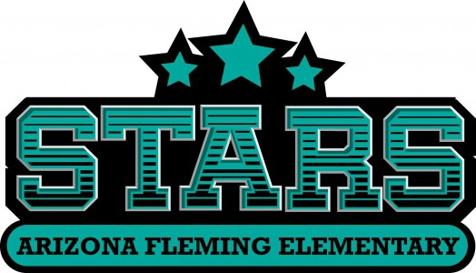
2025-2026 Campus Improvement Plan

Mission Statement
FBISD exists to inspire and equip all students to pursue futures beyond what they can imagine.
AFE Mission: AFE exists to empower a community of life-long learners through respect for diversity, good character, and a love for learning.

Vision
Fort Bend ISD will graduate students who exhibit the attributes of the District’s Profile of a Graduate.
AFE Vision: Arizona Fleming Elementary will create scholars who display attributes of the District’s Profile of a Graduate.

Value Statement
Welcome to Fleming University! We LEAD!

Table of Contents

Comprehensive Needs Assessment 4
Demographics 4
Student Learning 8
School Processes & Programs 16
Perceptions 18
Priority Problem Statements 19
Comprehensive Needs Assessment Data Documentation 21
Goals 23
Goal 1: Priority 1: Increase successful student outcomes through enhanced learning opportunities 23 Goal 2: Priority 2: Create and sustain a culture and climate of professionalism, accountability, and communication (PAC) where stakeholders (student, parents, and staff) are valued, inspired, and engaged. 30
Goal 3: Priority 3: Exhibit financial responsibility through transparent budgeting processes and effective management of resources aligned to the district strategic plan. 32 Addendums 34

Comprehensive Needs Assessment

Demographics

Demographics Summary
At AFE, one of our most significant demographic strengths is the diversity present within our student body, faculty, staff, and families. This rich tapestry of backgrounds and perspectives enhances the educational experiences of our students, providing them with a broader understanding of the world and fostering an environment of inclusivity and respect. By embracing our differences, we are able to implement strategic approaches that not only maximize student learning but also enhance academic exposure and achievement across the board.
The collaboration between teachers, parents, and campus personnel create a supportive network that benefits our students, ensuring they have the resources and encouragement needed to thrive. Our community is united in its commitment to doing what is best for our students, working together to provide a nurturing and empowering educational environment.
We are dedicated to delivering a consistent message of building a community characterized by acceptance, persistence, diligence, and growth. This shared vision guides our efforts and inspires our students to strive for excellence, fostering a culture where every individual is encouraged to reach their full potential. Through this commitment, we aim to prepare our students not only for academic success but also for meaningful contributions to society.
Arizona Fleming is a diverse campus. As a campus, the Hispanic population continues to increase over the past 4 years. Students served in Special Education programs also continues to increase as the campus teams are able to identify students needing additional learning services at the campus level. Student identification in the areas of Learning Disabled, Autism, and Speech have continued to increase since the 2021-2022.
Enrollment Numbers:
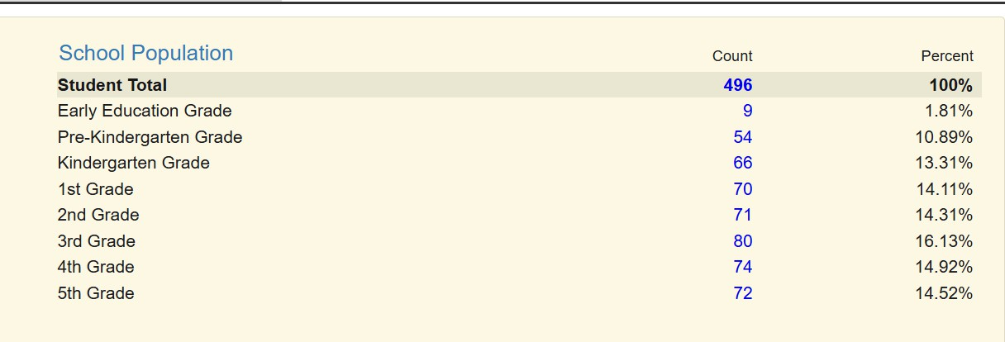

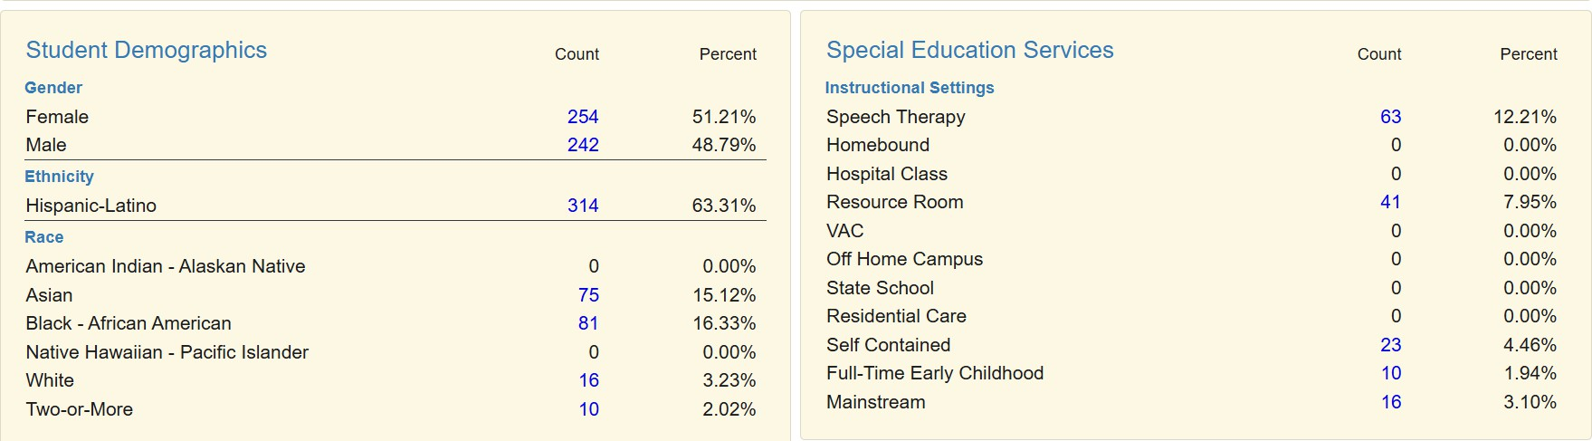
Demographics:

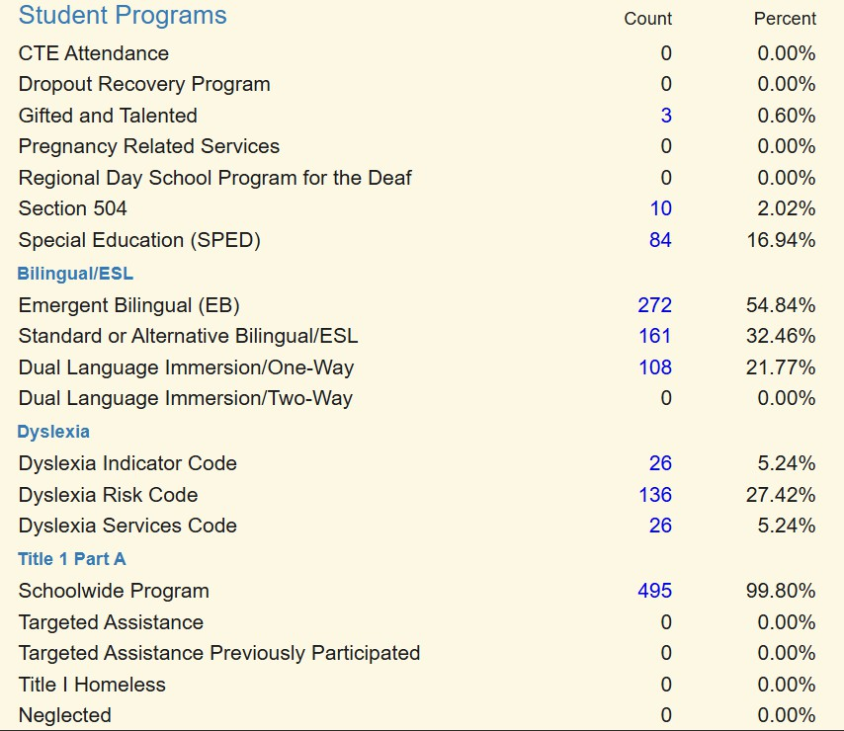

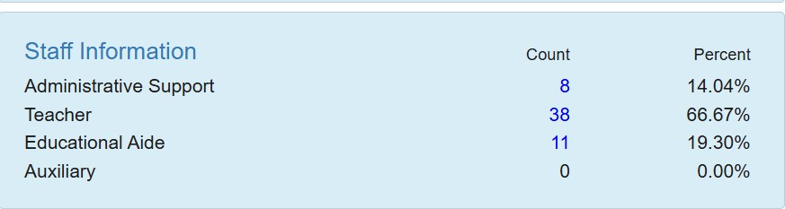

Attendance:
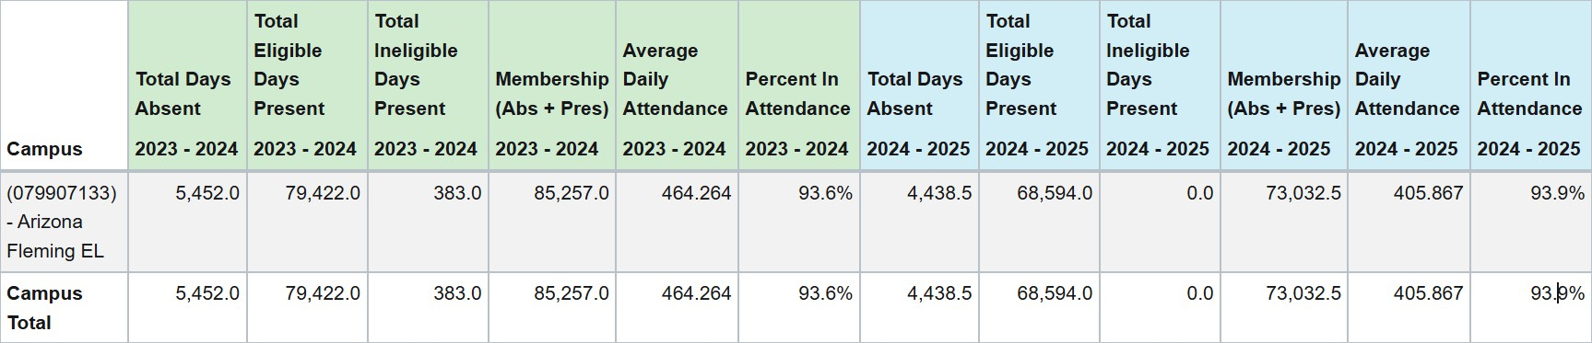

Demographics Strengths
AFE demographic strengths include the following:
Student diversity Number of Certified staff
Moderate student mobility – Enrollment (415) Optimal staff to student ratio
Cultural Proficiency
Improvement from 23-24 to 24-25 in attendance by .3%

Problem Statements Identifying Demographics Needs
Problem Statement 1 (Prioritized): Only 0.60 % of students are identified for Gifted and Talented services, which is low given the size of the campus and diversity, correlates with the number of students who have mastered on state testing.
Root Cause: Teacher support in identifying students with giftedness in diverse populations as well as growing students in areas for higher achievement.

Problem Statement 2 (Prioritized): Our average daily attendance rate was 93.9 in 2024-25, which was below the district goal of 95%.
Root Cause: Our attendance is low due to parental and student engagement. The daily attendance percentage will vary greatly based on inclement weather, medical appointments, late arrivals, care for younger siblings, and support structures at home.

Student Learning

Student Learning Summary
AFE students show continued growth in reading and science according to the STAAR data. Tier 1 instruction, the implementation of small group instruction, AFE intervention hour, and data driven instructional practices have contributed to student academic growth. Increased student achievement is the key focus for this upcoming school year.

Achievement Data
NWEA
Math
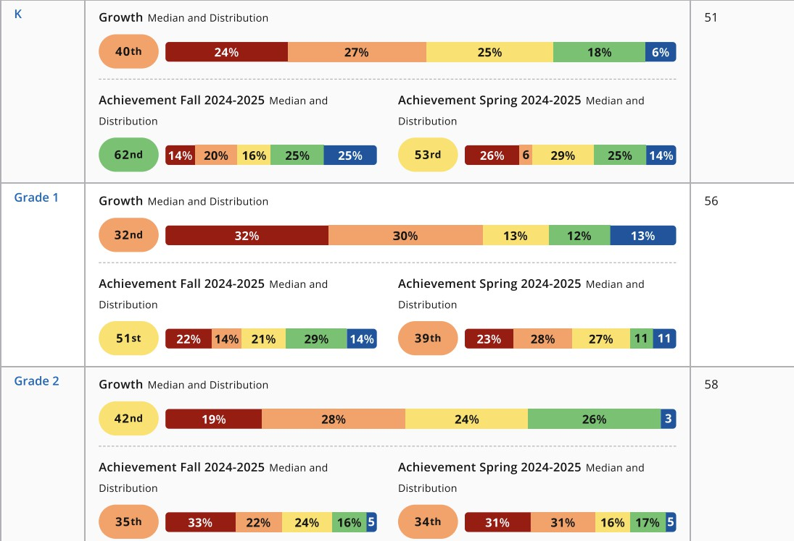

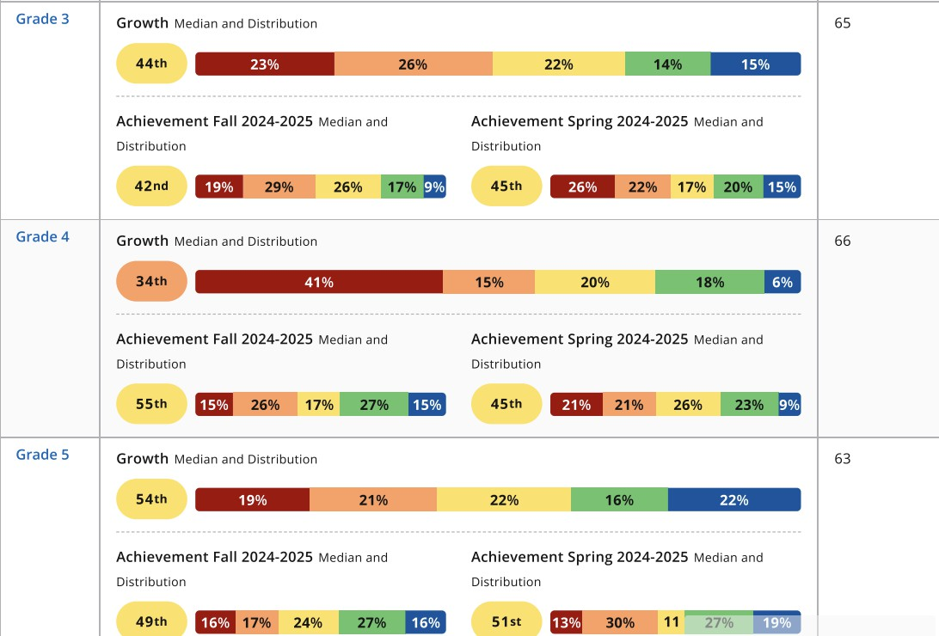

Reading -English
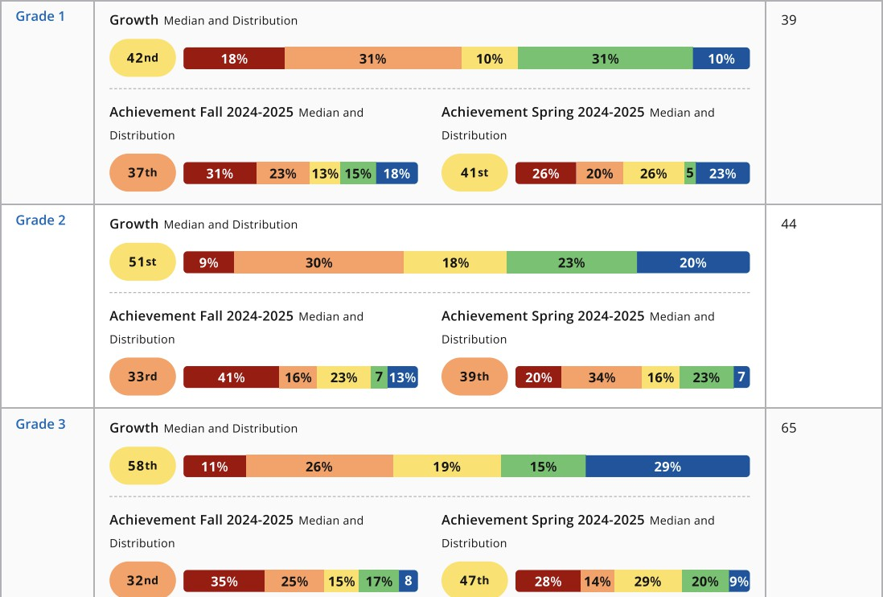
Reading-Spanish

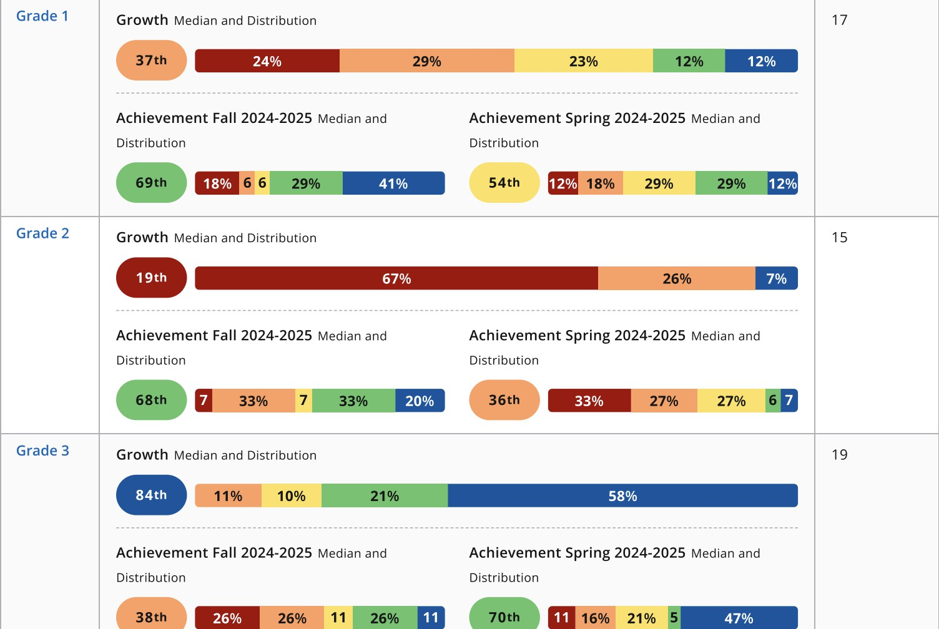
STAAR 3-5 Math
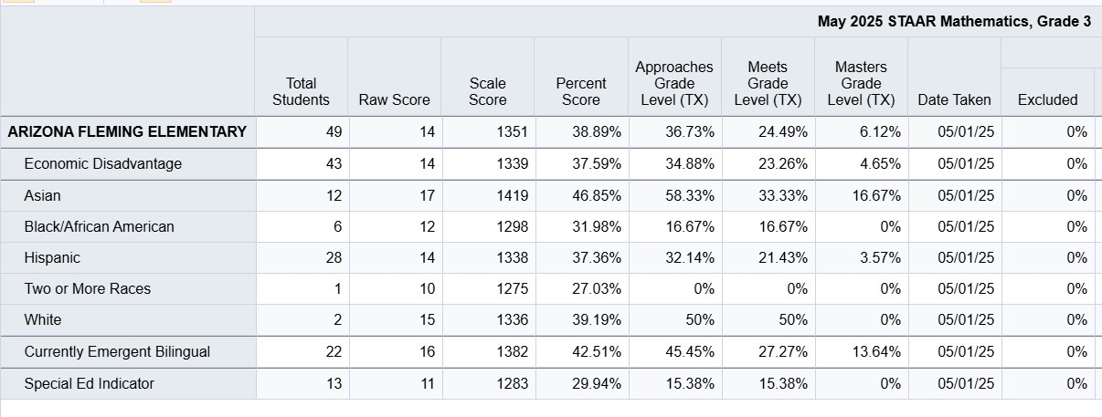

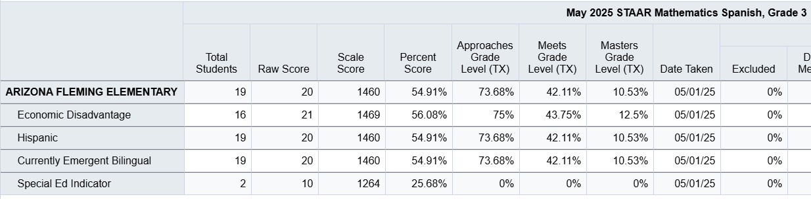
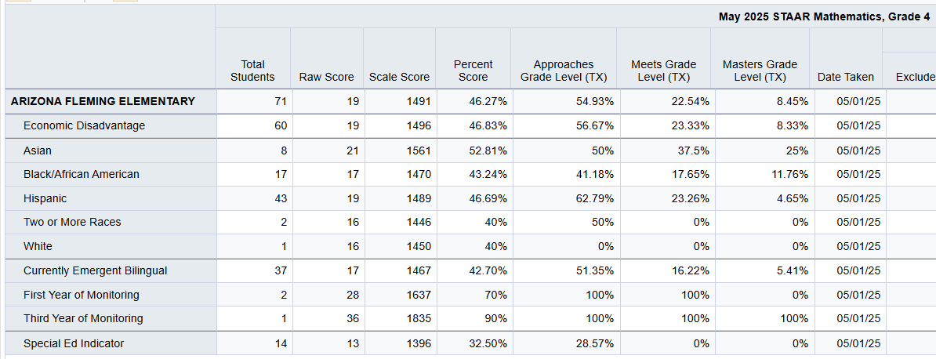
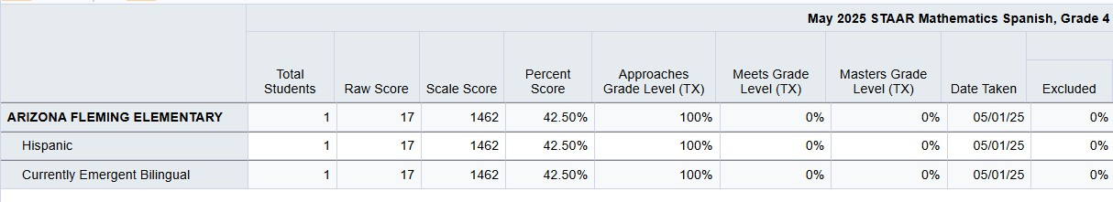

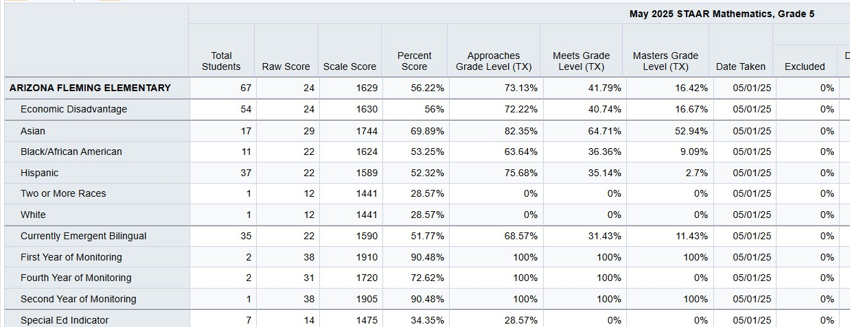

STAAR 3-5 Reading
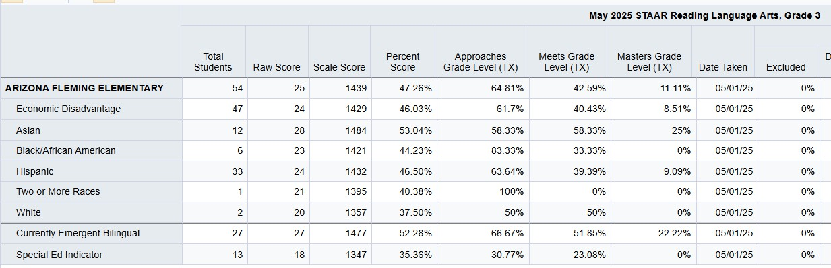
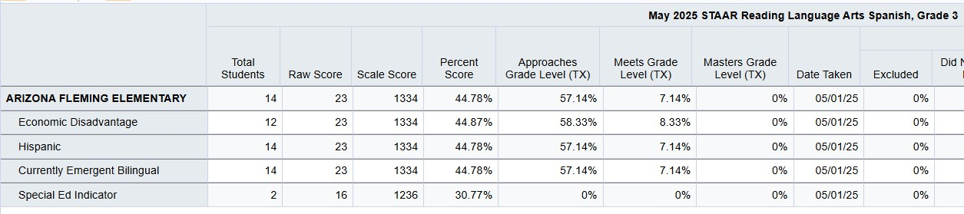

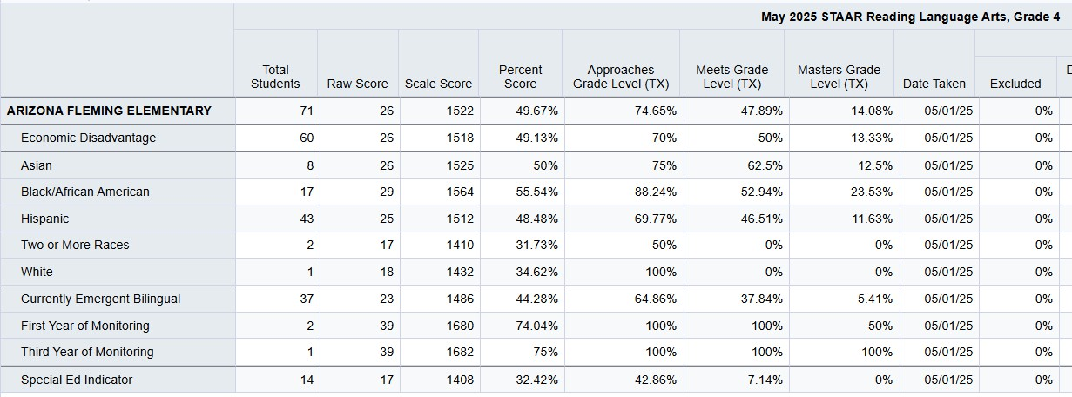
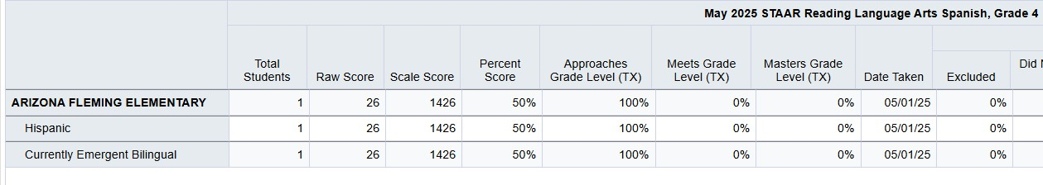
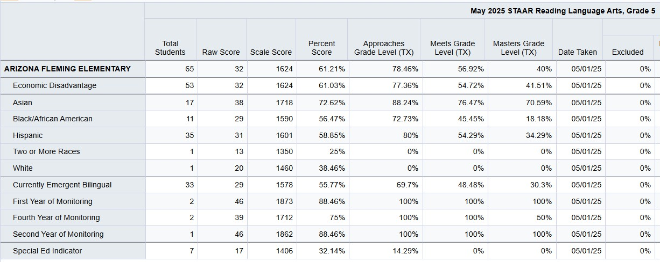
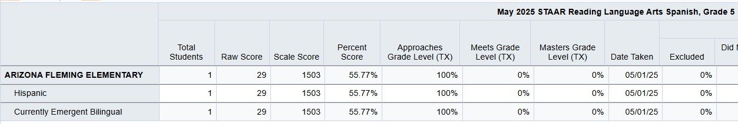

Student Learning Strengths
AFE Student learning strengths:

Over the course of the school year, student learning outcomes have shown clear and measurable progress. NWEA MAP data reveals a notable increase in proficiency levels in Reading, with K–2 students benefiting from targeted small-group instruction that has strengthened foundational literacy skills. Universal screener results indicate that academic growth has been both maintained and increased, and the percentage of students reading at or above benchmark rose steadily from the start of the year through May.
The Student Support Team (SST) has refined its processes for monitoring interventions, ensuring timely and effective next steps that directly impact student growth. Similarly, the Special Education department has increased its efficiency in moving forward with referrals, resulting in appropriate and timely support for students in need. In science, an intentional focus on lab-based learning has enhanced instruction and provided more hands-on opportunities for exploration.
Gifted and Talented (GT) identification has increased, reflecting a broader recognition of diverse student strengths. Attendance has also seen gradual improvement, contributing to greater instructional consistency. Finally, CST data shows stronger curriculum alignment and an emphasis on authentic learning experiences, helping to bridge academic standards with real-world application. Together, these strengths highlight a year of intentional growth, collaboration, and student-centered progress.

Problem Statements Identifying Student Learning Needs
Problem Statement 1 (Prioritized): Early literacy assessment data indicates that fifty percent or more of AFE students in grades K-2nd are not at the expected reading level.
Root Cause: Phonics instruction not consistently implemented throughout the school year.
Problem Statement 2 (Prioritized): Multiple data sources for EOY including NWEA MAP, STAAR and campus assessments show a need to build teacher capacity in instructional strategies to support and grow more Sped, EL, At-Risk, and other student demographics.
Root Cause: Teachers are not utilizing time management strategies for continued professional growth and collaboration needed to address rigor of standard
Problem Statement 3 (Prioritized): Multiple data sources for MOY & EOY including NWEA MAP, DLAs and campus assessments show that our students have insufficient foundational skills in literacy, numeracy, and science.
Root Cause: Effective and consistent Tier 1 instruction, small groups, intentional intervention are needed in every classroom. Teachers are in the developing stages in their understanding of the standards to be taught at the depth of knowledge needed for students to demonstrate mastery of the concept.
Problem Statement 4 (Prioritized): As a campus we need to make strides to increase student achievement in meets and masters on the universal screener NWEA MAP and STAAR. We also need to increase the reading and math fluency of students before they exit grades K-2.
Root Cause: Students transitioning from year to year, rigor of Tier 1 instruction, missing instruction, gaps in foundational skills and lack of enrichment opportunities. Consistent practice, resources and structures for reading and math fluency are needed.

School Processes & Programs

School Processes & Programs Summary
The area of focus for Arizona Fleming was Clarity of Content. Teachers engaged in PLCs to strengthen their understanding in Tier I instruction with campus and district support. Teachers focused on targeted assessments, data-driven instructional practices, small group instruction, and targeted interventions. Teachers collaborated and addressed rigor of standards, lesson differentiation, and practice instructional strategies needed to support Sped, EL, At-Risk, and other student demographics.
Teachers and staff are making gains in implementing highly effective Tier I instruction by aligning the content and pedagogical knowledge derived from PLCs and PD opportunities with the learner experience. While strides have been made, there is a need for less dependence on student growth and more focus on student achievement.
AFE utilizes informal walk data to determine trends and provide PD. Campus PD days provided intentional learning experiences by grade-level/content to ensure that teachers receive pertinent information to support their roles.
As part of the learning walk observation look-fors, instructional leadership team members observe the use of district-approved resources such as Fontas and Pinnell, ST Math, etc. in use. Instructional coaches support planning and implementation of curriculum resources through PLCs. Grade level teachers participated in extended PLCs on a 7-day rotation from 7:50-8:50 am where the instructional leadership team support unit/concept planning and data review.
Interventionists utilized the district resources, LLI & Number Worlds, to provide instruction at the student's instructional level during groups.
Administration utilized Title 1 funding to provide support in instruction with K-12 Summit. Additionally, Achieve 3000 was provided to grades 3-5 to support literacy instruction and use for intervention time.

School Processes & Programs Strengths School Processes and Programs Strengths:
Effective presenters during PD’s & PLC’s ; PD provided and funded supported teachers in their current roles; PLCs provided opportunities for teachers to build collective efficacy and understanding of their content and instructional practices.
Coaching cycles with coaches
Coaches provide optional planning days
Interventionists and grade level liaisons provide supports Mentors provided to new teachers/teachers new to grade level Materials & resources available & provided
Improved use of DDI protocols to grow students academically Some teachers are proficient in content knowledge
Achieve3000 provides supports for EBs, SPED, and struggling learners by providing text at their instructional level with build in accommodations.

Celebration and acknowledgement of student academic success Active participation in clubs and campus programs
Parents in attendance for CPAC meeting

Problem Statements Identifying School Processes & Programs Needs
Problem Statement 1 (Prioritized): TTESS, CST, and other walk-through data sources indicate that lessons are not rigorous to ensure student growth and achievement.
Root Cause: Teachers are learning how to lesson plan using the lesson cycle, including unpacking of TEKS through the unit and concept planning actions to align to the rigor of state standards.
Problem Statement 2 (Prioritized): Campus Culture and Climate Survey indicates that school wide PBIS expansion is needed because students are not excited to come to school.
Root Cause: Students feel that there is not enough enrichment opportunities, after school programs, and PBIS positive initiatives for ALL students.

Perceptions

Perceptions Summary
The school climate survey reveals that parents are not updated regarding student progress.
Staff shared that administration is respectful and caring for students and staff. Teachers indicate through the principal climate survey that there is a need for additional communication. Currently, a weekly newsletter is provided, calendar invites are shared for due dates and faculty meetings are held bi-weekly to communicate updates/reminders. One staff member indicated the need for all staff to find out information at the same time (as some information is provided through team leaders, committees, etc.). Teachers also indicated in the survey a need for additional visibility. After discussion with the teachers, they agreed that administration is on morning and PM duty (if not in PLCs), conducts classroom walks, recess/lunch visits, and attend all after school activities. Staff asked for additional classroom walks to support visibility.

Perceptions Strengths
Survey results reflect strong confidence in the campus climate and its support for students and families.
Relevance in Academics: Parents recognize that the schoolwork that students complete are relevant to their daily lives and impact students outside of school. Survey data shows this strength at 82%.
Embracing Diversity: 86% of families feel the campus embraces diversity, fostering an inclusive environment through different diverse celebrations that occur on the campus as well as effective communication.
Safe and Secure Campus Environment: Safety and student support are priorities for parents as parents recognize that there are staff member who care about their child and can assist with problems.
Ongoing Family Engagement: Parents also feel that there are engagement events that support family involvement and it is encouraged with survey data showing this strength at 86%.

Problem Statements Identifying Perceptions Needs
Problem Statement 1 (Prioritized): Based on the Campus Culture and Climate survey, families report that students are not equipped with skills for future and are lacking academic support.
Root Cause: Real world applications are not integrated into instruction consistently.

Priority Problem Statements
Problem Statement 1: Only 0.60 % of students are identified for Gifted and Talented services, which is low given the size of the campus and diversity, correlates with the number of students who have mastered on state testing.
Root Cause 1: Teacher support in identifying students with giftedness in diverse populations as well as growing students in areas for higher achievement.
Problem Statement 1 Areas: Demographics

Problem Statement 2: Our average daily attendance rate was 93.9 in 2024-25, which was below the district goal of 95%.
Root Cause 2: Our attendance is low due to parental and student engagement. The daily attendance percentage will vary greatly based on inclement weather, medical appointments, late arrivals, care for younger siblings, and support structures at home.
Problem Statement 2 Areas: Demographics

Problem Statement 3: Early literacy assessment data indicates that fifty percent or more of AFE students in grades K-2nd are not at the expected reading level.
Root Cause 3: Phonics instruction not consistently implemented throughout the school year.
Problem Statement 3 Areas: Student Learning

Problem Statement 4: Multiple data sources for EOY including NWEA MAP, STAAR and campus assessments show a need to build teacher capacity in instructional strategies to support and grow more Sped, EL, At-Risk, and other student demographics.
Root Cause 4: Teachers are not utilizing time management strategies for continued professional growth and collaboration needed to address rigor of standard
Problem Statement 4 Areas: Student Learning

Problem Statement 5: Multiple data sources for MOY & EOY including NWEA MAP, DLAs and campus assessments show that our students have insufficient foundational skills in literacy, numeracy, and science.
Root Cause 5: Effective and consistent Tier 1 instruction, small groups, intentional intervention are needed in every classroom. Teachers are in the developing stages in their understanding of the standards to be taught at the depth of knowledge needed for students to demonstrate mastery of the concept.
Problem Statement 5 Areas: Student Learning

Problem Statement 6: As a campus we need to make strides to increase student achievement in meets and masters on the universal screener NWEA MAP and STAAR. We also need to increase the reading and math fluency of students before they exit grades K-2.
Root Cause 6: Students transitioning from year to year, rigor of Tier 1 instruction, missing instruction, gaps in foundational skills and lack of enrichment opportunities. Consistent practice, resources and structures for reading and math fluency are needed.
Problem Statement 6 Areas: Student Learning

Problem Statement 7: TTESS, CST, and other walk-through data sources indicate that lessons are not rigorous to ensure student growth and achievement.

Root Cause 7: Teachers are learning how to lesson plan using the lesson cycle, including unpacking of TEKS through the unit and concept planning actions to align to the rigor of state standards.
Problem Statement 7 Areas: School Processes & Programs

Problem Statement 8: Campus Culture and Climate Survey indicates that school wide PBIS expansion is needed because students are not excited to come to school.
Root Cause 8: Students feel that there is not enough enrichment opportunities, after school programs, and PBIS positive initiatives for ALL students.
Problem Statement 8 Areas: School Processes & Programs

Problem Statement 9: Based on the Campus Culture and Climate survey, families report that students are not equipped with skills for future and are lacking academic support.
Root Cause 9: Real world applications are not integrated into instruction consistently.
Problem Statement 9 Areas: Perceptions

Comprehensive Needs Assessment Data Documentation
The following data were used to verify the comprehensive needs assessment analysis:

Improvement Planning Data
District goals Campus goals
HB3 Reading and math goals for PreK-3
Performance Objectives with summative review (prior year) Campus/District improvement plans (current and prior years) Planning and decision making committee(s) meeting data
State and federal planning requirements

Accountability Data
Texas Academic Performance Report (TAPR) data Student Achievement Domain
Student Progress Domain Closing the Gaps Domain
Comprehensive, Targeted, and/or Additional Targeted Support Identification data Accountability Distinction Designations
Federal Report Card and accountability data Local Accountability Systems (LAS) data

Student Data: Assessments
State and federally required assessment information
STAAR current and longitudinal results, including all versions STAAR Emergent Bilingual (EB) progress measure data
Texas English Language Proficiency Assessment System (TELPAS) and TELPAS Alternate results Student failure and/or retention rates
Observation Survey results
Prekindergarten Self-Assessment Tool
Texas approved PreK - 2nd grade assessment data
Grades that measure student performance based on the TEKS

Student Data: Student Groups
Race and ethnicity data, including number of students, academic achievement, discipline, attendance, and rates of progress between groups
Special programs data, including number of students, academic achievement, discipline, attendance, and rates of progress for each student group Economically disadvantaged / Non-economically disadvantaged performance and participation data
Male / Female performance, progress, and participation data
Special education/non-special education population including discipline, progress and participation data Section 504 data
Homeless data

Gifted and talented data Dyslexia data
Response to Intervention (RtI) student achievement data

Student Data: Behavior and Other Indicators
Attendance data
Discipline records
Student surveys and/or other feedback School safety data
Enrollment trends

Employee Data
Professional learning communities (PLC) data Staff surveys and/or other feedback
Teacher/Student Ratio
State certified and high quality staff data Campus leadership data
Professional development needs assessment data
Evaluation(s) of professional development implementation and impact T-TESS data

Parent/Community Data
Parent surveys and/or other feedback Parent engagement rate
Community surveys and/or other feedback

Support Systems and Other Data
Organizational structure data
Processes and procedures for teaching and learning, including program implementation Communications data
Capacity and resources data
Budgets/entitlements and expenditures data Action research results

Goals
Goal 1: Priority 1: Increase successful student outcomes through enhanced learning opportunities

Performance Objective 1: By May 2026, Arizona Fleming will improve instructional effectiveness in literacy, as demonstrated by at least a 5% increase in K-5 end-of-year NWEA Map Growth Reading scores.

High Priority HB3 Goal
Evaluation Data Sources: NWEA Map Growth Summary Report NWEA Student Progress Report
NWEA School Profile Report

Strategy 1 Details | Reviews
Strategy 1: Use of District's PLC and formative assessment cycle to plan rigorous lessons that are engaging and responsive to students' needs.  Strategy's Expected Result/Impact: Increase by at least 5% in K-5 Reading Growth scores  Staff Responsible for Monitoring: Administration and AFE coaches  TEA Priorities:  Build a foundation of reading and math  - ESF Levers:  Lever 4: High-Quality Instructional Materials and Assessments, Lever 5: Effective Instruction  - Targeted Support Strategy - Additional Targeted Support Strategy | Formative |  |  | Summative
 | Oct | Dec | Feb | June
Strategy 2 Details | Reviews
Strategy 2: Use of District PLC protocols aligned to the district's PLC process.  Strategy's Expected Result/Impact: Increase by at least 5% in K-5 Reading Growth scores  Staff Responsible for Monitoring: AFE Instructional Leadership Team (Admin, Coaches, Specialists)  TEA Priorities:  Build a foundation of reading and math  - ESF Levers:  Lever 4: High-Quality Instructional Materials and Assessments, Lever 5: Effective Instruction  - Additional Targeted Support Strategy | Formative |  |  | Summative
 | Oct | Dec | Feb | June

Strategy 3 Details | Reviews
Strategy 3: Students will participate in RLA related field trips to support classroom learning.  Strategy's Expected Result/Impact: Increase by at least 5% in K-5 Reading Growth scores  Staff Responsible for Monitoring: Administration, grade-level team leaders  TEA Priorities:  Build a foundation of reading and math  - ESF Levers:  Lever 3: Positive School Culture | Formative |  |  | Summative
 | Oct | Dec | Feb | June
Strategy 4 Details | Reviews
Strategy 4: Teachers will plan and implement daily small group instruction for literacy and align instruction to the literacy instructional model.  Strategy's Expected Result/Impact: Increase by at least 5% in K-5 Reading Growth scores  Staff Responsible for Monitoring: Administration and Coaches  TEA Priorities:  Build a foundation of reading and math  - ESF Levers:  Lever 4: High-Quality Instructional Materials and Assessments, Lever 5: Effective Instruction  - Additional Targeted Support Strategy | Formative |  |  | Summative
 | Oct | Dec | Feb | June
 No Progress  Accomplished  Continue/Modify  Discontinue

Goal 1: Priority 1: Increase successful student outcomes through enhanced learning opportunities

Performance Objective 2: By May 2026, AFE will improve the effectiveness of math instruction, as demonstrated by at least 10% increase in amount of students at least approaching on 3-5 Math STAAR.

High Priority HB3 Goal
Evaluation Data Sources: STAAR 2025 STAAR Interim Spring 2026
STAAR 2026
3-5th NWEA Map Growth Math Student and School Reports 3-5th District/Campus CFAs

Strategy 1 Details | Reviews
Strategy 1: Use of District's PLC and formative assessment cycle to plan rigorous lessons that are engaging and responsive to students' needs.  Strategy's Expected Result/Impact: Increase by at least 10% on 3-5 Math STAAR  Staff Responsible for Monitoring: Administration and Coaches  TEA Priorities:  Build a foundation of reading and math  - ESF Levers:  Lever 4: High-Quality Instructional Materials and Assessments, Lever 5: Effective Instruction  - Targeted Support Strategy - Additional Targeted Support Strategy | Formative |  |  | Summative
 | Oct | Dec | Feb | June
Strategy 2 Details | Reviews
Strategy 2: Use of District PLC protocols aligned to the district's PLC process.  Strategy's Expected Result/Impact: Teacher clarity of instruction and how to connect instructional practices, resources, and tasks to student learning outcomes.  Staff Responsible for Monitoring: AFE Instructional Leadership Team  TEA Priorities:  Build a foundation of reading and math  - ESF Levers:  Lever 4: High-Quality Instructional Materials and Assessments, Lever 5: Effective Instruction  - Targeted Support Strategy - Additional Targeted Support Strategy | Formative |  |  | Summative
 | Oct | Dec | Feb | June

Strategy 3 Details | Reviews
Strategy 3: Provide Instructional Model Professional Development to Staff for best practice in math instructional delivery.  Strategy's Expected Result/Impact: Increase by at least 10% on 3-5 Math STAAR  Staff Responsible for Monitoring: AFE Instructional Leadership Team  TEA Priorities:  Build a foundation of reading and math  - ESF Levers:  Lever 4: High-Quality Instructional Materials and Assessments, Lever 5: Effective Instruction  - Additional Targeted Support Strategy | Formative |  |  | Summative
 | Oct | Dec | Feb | June
Strategy 4 Details | Reviews
Strategy 4: Students will participate in STEM related field trips to support classroom learning.  Strategy's Expected Result/Impact: Students will engage in hands on activities and understand relevancy in their learning to make better connections.  Staff Responsible for Monitoring: Administration, grade-level team leaders  TEA Priorities:  Build a foundation of reading and math  - ESF Levers:  Lever 1: Strong School Leadership and Planning, Lever 4: High-Quality Instructional Materials and Assessments | Formative |  |  | Summative
 | Oct | Dec | Feb | June
Strategy 5 Details | Reviews
Strategy 5: The campus will utilize online a learning platform to support math intervention and enrichment that supports the district's curriculum.  Strategy's Expected Result/Impact: Increase by at least 10% on 3-5 Math STAAR  Staff Responsible for Monitoring: Administration and Coaches  TEA Priorities:  Build a foundation of reading and math  - ESF Levers:  Lever 4: High-Quality Instructional Materials and Assessments, Lever 5: Effective Instruction  - Additional Targeted Support Strategy | Formative |  |  | Summative
 | Oct | Dec | Feb | June
Strategy 6 Details | Reviews
Strategy 6: Teachers will plan and implement small group 4-5 days per week in instruction for math.  Strategy's Expected Result/Impact: Increase by at least 10% on 3-5 Math STAAR  Staff Responsible for Monitoring: Administration and Coaches | Formative |  |  | Summative
 | Oct | Dec | Feb | June

No Progress Accomplished Continue/Modify Discontinue

Goal 1: Priority 1: Increase successful student outcomes through enhanced learning opportunities

Performance Objective 3: By June 2026, AFE will improve the effectiveness of tier 1 instruction as it relates to supporting emergent bilingual students, as demonstrated by 10% as evidenced on TELPAS assessments.
Evaluation Data Sources: TELPAS 2026 District/Campus CFAs
NWEA Map Growth Reports TELPAS 2026

Strategy 1 Details | Reviews
Strategy 1: Strengthen Tier 1 Instruction with Language-Rich Practices, including embedding daily academic vocabulary instruction across all content areas with visual, oral, and written supports.  Strategy's Expected Result/Impact: Increase in proficiency levels by 10% on TELPAS  Staff Responsible for Monitoring: Administration, Coaches, and Specialist  TEA Priorities:  Recruit, support, retain teachers and principals  - ESF Levers:  Lever 1: Strong School Leadership and Planning, Lever 4: High-Quality Instructional Materials and Assessments, Lever 5: Effective Instruction | Formative |  |  | Summative
 | Oct | Dec | Feb | June
Strategy 2 Details | Reviews
Strategy 2: Integrate ongoing TELPAS-Aligned Language Practice, including aligning instructional tasks to TELPAS language domains(listening, speaking, reading and writing) with intentional practice.  Strategy's Expected Result/Impact: Increase in proficiency levels by 10% on TELPAS  Staff Responsible for Monitoring: Administration, Coaches, and Bilingual Specialist | Formative |  |  | Summative
 | Oct | Dec | Feb | June
Strategy 3 Details | Reviews
Strategy 3: Build Teacher Capacity through Professional Learning and Collaboration, including providing targeted professional development on scaffolding strategies, culturally responsive teaching and integration language objects with content objectives.  Strategy's Expected Result/Impact: Increase in proficiency levels by 10% on TELPAS  Staff Responsible for Monitoring: Administration, Coaches, and Bilingual Specialist  ESF Levers:  Lever 4: High-Quality Instructional Materials and Assessments, Lever 5: Effective Instruction | Formative |  |  | Summative
 | Oct | Dec | Feb | June

No Progress Accomplished Continue/Modify Discontinue

Goal 2: Priority 2: Create and sustain a culture and climate of professionalism, accountability, and communication (PAC) where stakeholders (student, parents, and staff) are valued, inspired, and engaged.

Performance Objective 1: By May 2026, based on the FBISD student engagement survey, students will demonstrate a 5% increase in their overall understanding of the school-wide rules and their fairness.
Evaluation Data Sources: FBISD's Culture and Climate and Student Engagement Survey Results

Strategy 1 Details | Reviews
Strategy 1: AFE will implement Morning Meetings campus wide.  Strategy's Expected Result/Impact: This initiative will support strong character among staff and students while creating a strong sense of belonging for students and families.  Staff Responsible for Monitoring: Principal, Asst. Principal and Counselor  TEA Priorities:  Recruit, support, retain teachers and principals  - ESF Levers:  Lever 3: Positive School Culture | Formative |  |  | Summative
 | Oct | Dec | Feb | June
Strategy 2 Details | Reviews
Strategy 2: AFE's PBIS committee will create, adopt, and implement the PBIS store.  Strategy's Expected Result/Impact: Consistent procedures and expectations will be established and utilized across the campus to create a fair and positive learning environment.  Staff Responsible for Monitoring: Principal Asst. Principal  Counselor PBIS team  TEA Priorities:  Recruit, support, retain teachers and principals  - ESF Levers:  Lever 1: Strong School Leadership and Planning, Lever 3: Positive School Culture | Formative |  |  | Summative
 | Oct | Dec | Feb | June
No Progress Accomplished Continue/Modify Discontinue

Goal 2: Priority 2: Create and sustain a culture and climate of professionalism, accountability, and communication (PAC) where stakeholders (student, parents, and staff) are valued, inspired, and engaged.

Performance Objective 2: By May 2026, based on the FBISD parent engagement survey, parents will demonstrate an 8% increase as it relates to overall school quality.

Strategy 1 Details | Reviews
Strategy 1: AFE will strengthen communication channels by providing consistent and transparent communication through newsletters, emails, and social media; while also establishing a stronger relationship with our PTA to gather input from staff, families, and students.  Strategy's Expected Result/Impact: Improvement of 8% increase of overall school quality.  Staff Responsible for Monitoring: Administration, Parent Educator  ESF Levers:  Lever 3: Positive School Culture | Formative |  |  | Summative
 | Oct | Dec | Feb | June
Strategy 2 Details | Reviews
Strategy 2: AFE will improve parent partnerships in the school including maintaining a PTO as well as inviting parents into the school for multiple events and opportunities  Strategy's Expected Result/Impact: Improvement of 8% increase of overall school quality.  Staff Responsible for Monitoring: Administration, Counselor, Parent Engagement Specialist  ESF Levers:  Lever 1: Strong School Leadership and Planning, Lever 3: Positive School Culture | Formative |  |  | Summative
 | Oct | Dec | Feb | June
No Progress Accomplished Continue/Modify Discontinue

Goal 3: Priority 3: Exhibit financial responsibility through transparent budgeting processes and effective management of resources aligned to the district strategic plan.

Performance Objective 1: By May 2026, Arizona Fleming Elementary administration will ensure 100% efficient staffing in all teacher and instructional paraprofessional positions.
Evaluation Data Sources: FBISD Staffing Guidelines FBISD Campus Projections
Monthly morale activities

Strategy 1 Details | Reviews
Strategy 1: AFE will ensure to celebrate staff achievement monthly to increase teacher morale.  Strategy's Expected Result/Impact: Increase efficient staffing and retain effective staff  Staff Responsible for Monitoring: Administration, Sunshine Committee (Culture & Climate)  ESF Levers:  Lever 1: Strong School Leadership and Planning | Formative |  |  | Summative
 | Oct | Dec | Feb | June
No Progress Accomplished Continue/Modify Discontinue

Goal 3: Priority 3: Exhibit financial responsibility through transparent budgeting processes and effective management of resources aligned to the district strategic plan.

Performance Objective 2: By May 2026, Arizona Fleming Elementary will demonstrate fiscal responsibility by ensuring 100% of all instructional resources purchased are within the campus budget allotment and aligned to campus priorities to improve student outcomes and meet instructional needs.
Evaluation Data Sources: FBISD Budgeting Guidelines

Strategy 1 Details | Reviews
Strategy 1: AFE will continue to review budget allocations to ensure spending aligns with the district's strategic plan and campus priorities.  Strategy's Expected Result/Impact: AFE Budgeting Allocations  Staff Responsible for Monitoring: Executive Assistant and Principal  ESF Levers:  Lever 1: Strong School Leadership and Planning | Formative |  |  | Summative
 | Oct | Dec | Feb | June
No Progress Accomplished Continue/Modify Discontinue

Addendums

LOCATION | LOC_DESCR | DEPT_DESC | POSN_DESCR | HEADCOUNT | LAST_NAME_SRCH | FIRST_NAME_SRCH | FTE | PROGRAM_CODE | DEPTID_CF | EMPL_STA | REPORTS_TO_DESCR
133 ARIZONA FLEMING | ARIZONA FL | ARIZONA FL | AIDE PRE-KINDERGARTEN | 0.5 | FERNANDEZ | ANDREA | 1 | 30 | 133 | A | PRINCIPAL ELEM
133 ARIZONA FLEMING | ARIZONA FL | ARIZONA FL | TEACHER MATH INTRVN ELEM T1 | 0.5 | GRANT | TASHA | 1 | 30 | 133 | A | PRINCIPAL ELEM
133 ARIZONA FLEMING | ARIZONA FL | ARIZONA FL | TEACHER GRADE PK BIL | 0.5 | GOMEZ | NORMA | 1 | 30 | 133 | A | PRINCIPAL ELEM
133 ARIZONA FLEMING | ARIZONA FL | ARIZONA FL | AIDE PRE-KINDERGARTEN | 0.5 | SHELTONLANGHAM | TERRESA | 1 | 30 | 133 | A | PRINCIPAL ELEM
133 ARIZONA FLEMING | ARIZONA FL | ARIZONA FL | TEACHER GRADE PK | 0.5 | MITTENDORF | JENNIFER | 1 | 30 | 133 | A | PRINCIPAL ELEM
133 ARIZONA FLEMING | ARIZONA FL | ARIZONA FL | AIDE PRE-KINDERGARTEN | 0.5 | CARDONA | NORMA | 1 | 30 | 133 | A | PRINCIPAL ELEM
133 ARIZONA FLEMING | ARIZONA FL | ARIZONA FL | TEACHER GRADE PK | 0.5 | TURZAK | LISA | 1 | 30 | 133 | A | PRINCIPAL ELEM
133 ARIZONA FLEMING | ARIZONA FL | ARIZONA FL | TEACHER LIT INTRVN | 1 | CHARKALIS | DEBRA | 1 | 30 | 133 | A | PRINCIPAL ELEM

